Electronic label image production

In the test phase, you can manually create an image of the electronic label. The method of making it is as follows:

1. Make BMP format pictures

2. Converted BMP format picture to a JSON message.

# Make BMP format pictures

This screen does not support gray scale. When making pictures, you need to make a pure black and white picture with 296*128 resolutions.

Note: The picture must be pure red (RGB: 255,0,0); pure black (RGB: 0,0,0); pure white (255,255,255) these three colors, the current tool only supports conversion of these three colors.

Example:

testpass.bmp.

The following uses the windows drawing tool as an example:

1, Windows attachment menu = "painting

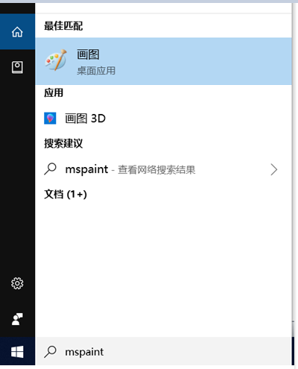

2. set the resolution to 296*128

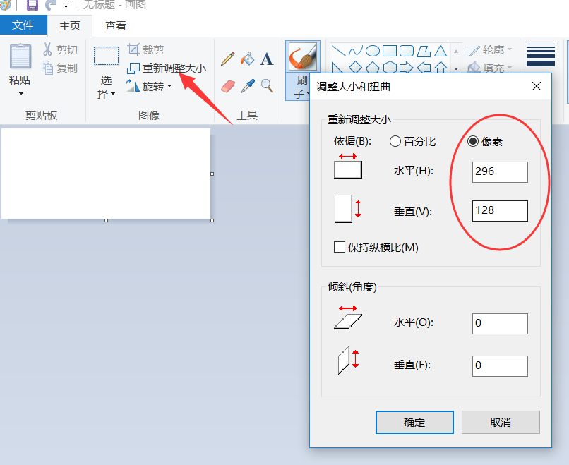

3, add text on the picture with a brush, you need to ensure that it is pure white (255, 255, 255); pure red: (255, 0, 0); pure black (0, 0, 0), you can choose in the editing color.

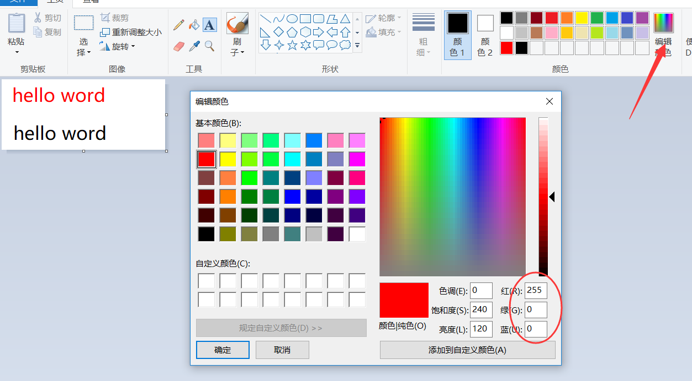

4. Save, please select the single 24 color bitmap to save.

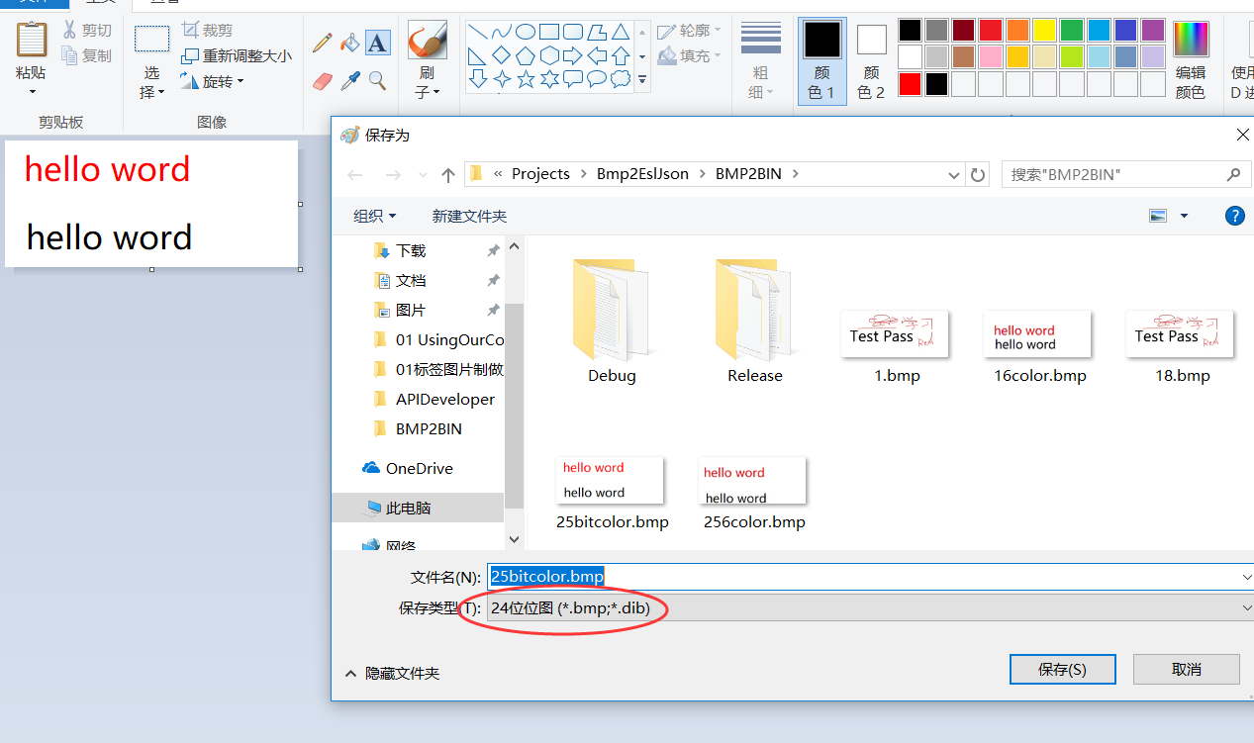

# Converted BMP format picture to a JSON message

## Step By Step to generate JSON message

1. Please put the BMP picture files generated in the previous step and Bmp2EslJson.exe in the same directory.

2, run the Bmp2EslJson.exe tool, the parameters you need to enter are as follows:

1. BIN file name.
2. ESL type: esl291
3. The password of the tag, the default is 8 0
4. The mac address of the device can be viewed through the gateway status monitoring to the 12-bit mac address.
5. The ID of the picture, you can enter a number arbitrarily, this is equivalent to the number of this picture.
6. JSON Message ID: identify about the json message, every download message should be different.

e) Whether compression: y

➢Compressing the image and then sending it will greatly reduce the refresh time.

After the carriage return, you will be prompted to write the JSON file successfully. You can see that a json file is generated in the same directory, which is the image update message.

Bmp2EslJson.exe is based on Visual Studio 2012 written in C/C++ language. The source code can be downloaded at:

Bmp2EslJson.zip

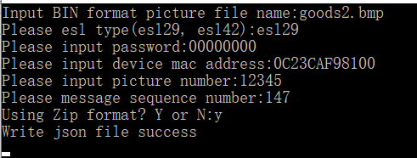

## One command to generate JSON message

1. Please put the BMP picture files generated in the previous step and Bmp2EslJson.exe in the same directory.

2. Execute following command

Bmp2EslJson.exe -f goods2.bmp -t e291 -p 00000000 -m 0C23CAF98100 -id 1478 -s 123 -z y

After the command is executed successfully, a JSON file will be generated. If the execution fails, a prompt error will be generated.

Paramaters:

-f: file name

-t: esl type: esl291

-p: password

-m: mac address

-id: picture id

-s: json message id

-z: compress mode, y means compress, n means not compress